Polarity of Pink and Black
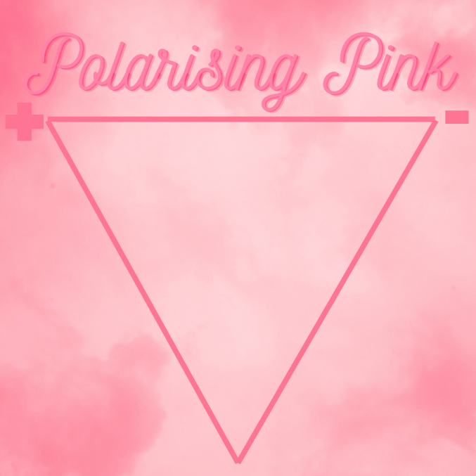
The polarity of pink is an interesting conundrum because, quite frankly, whoever thinks of pink as having a dark side.
On the positive side: pink is associated with compassion, love and femininity. It is a playful colour and has many different shades on a vast spectrum. Maybe you are not a pretty pink but maybe a vivid, loud pink is more your speed. Find it a bit to baby pink then maybe a coral, the colours we associate with the seabed.
Pink is often associated with being calming, sympathetic and approachable. The white undertones hint a purity and softness. The paler tones give a baby pink vibe or can be associated with purity. It is also a warm colour that elevates the spirit. Pink is perpetually upbeat and optimistic, often seen around valentine’s day.
Pink has a dark side too. It can be the colour of the over emotional, the timid and shy or those lacking confidence. It can also hint an immaturity. Those who ear it could be seeking attention or looking for someone to take care of them. Pink can also trigger nostalgia, often being associated with childhood. If there is childhood trauma it can be a trigger so approach with caution.
Most of the pink shades tend to blend in rather than shout out. It it not a particular showy colour until it gets towards the redder hues. Once you introduce the red tones it can be sultrier and more passionate, which can also be more attention seeking and take it rather harshly when those feelings are not reciprocated.
On a completely different note: Pink has a bit of a bad rap for being too girly. The colour stereotype says paint the girl’s room pink and the boy’s room in blue. Why should a colour be so polarising? Enevitably you expect to see lipsticks and barbie dolls! It used to be the other way round but after WW2, femininity got wrapped in pink, and so did products—from shampoos to fashion.

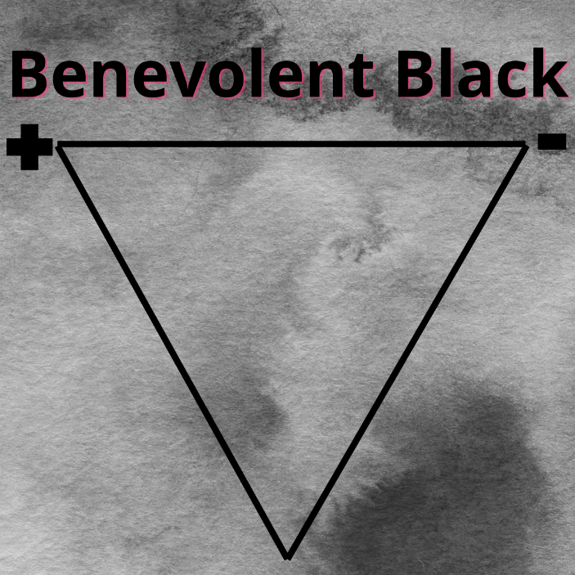
Likewise black has an equally bad rap. It is the absence of colour, it is the black hole. It is the domain of the 1980’s goth.
Black has a positive side: It symbolises power elegance and sophistication. Think of the little black dress or the top hat and tails. Traditionally black. Black has a sense of power to it. It is a colour used for formality and as such tends to represent formality, prestige and authority. For example most letters are written in black in or very dark grey. You can dress it up or dress it down so it blends in. A posh event is “Black tie”.
Black is often seen as a positive colour when talking about money, being referred to as “in the black”.
However black can also be a colour of mystery and intrigue.
The person wearing black possibly plays things close to their chest, not wanting to divulge their innermost thoughts. They want to stay mysterious. They want to be seen as sophisticated and in authority. Black is a powerhouse that stands out and turns heads.
The negative side of black: It is a colour that is associated with darkness, depressions, sadness, mourning, pessimism and dominance. Winston Churchill used to talk about his “Black Dog Days”, when he was overcome with depression and a feeling of foreboding.
Black is associated with many thinks sinister and evilr. It can feel empty and cold. The sky goes black before a thunderstorm. It can feel foreboding and darkly ominous.
On a completely different note: Black is also associated with the person that is seen as different. The “Black Sheep” of the family for example. An outcast from society. Or the “Men in Black” the secret society.
Black is very popular at the moment, with trendy interior designers using it on fence panels as a contrast or in a room to make it feel smaller and more cosy.

